Language Models 2

Source: https://people.ischool.berkeley.edu/~dbamman/nlp20_slides/7_LM_2.pdf

Feature Engineering
- Use n-grams, spelling, capitalization, custom grouping
- Limitations: more parameters, higher chance of overfitting
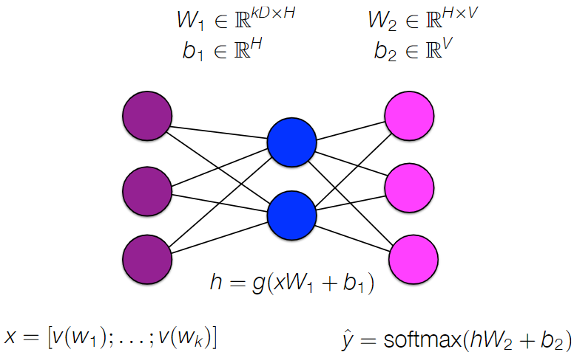
Multilayer perceptron (multi-class classification)
- Softmax layer:
- Normalizes output values which sum to 1
- Negative/small output becomes a small probability

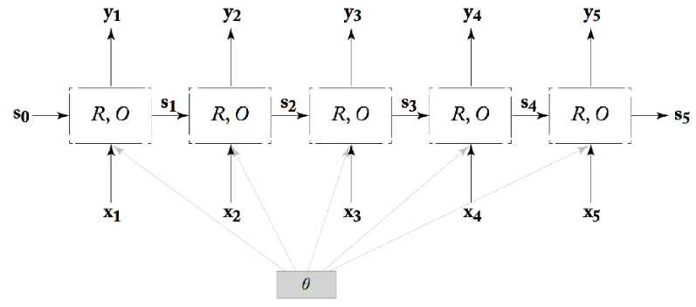

Recurrent neural network
- Allow arbitrary-sized contexts
- Possible architectures:
Continuous bag of words
Simple RNN | where g is tanh/RElu
RNN-LM | where g is tanh/RElu
- Limitations
  - Expensive to train for large vocabulary
  - Vanishing gradient problem

